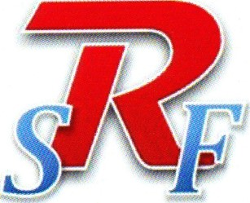
Revere Schools Foundation
Promote • Produce • Protect
The Revere Schools Foundation Presents the
Third Annual
ILLUMINATE 2018
Saturday, October 20, 2018
6:00 pm - 11:00 pm
3800 Embassy Parkway, Akron, Ohio 44333
It is with great pleasure that we invite you to Save the Date for Illuminate 2018. This is one of our most important signature events and is the key to financing the programs that support children in the Revere School District.
The Revere Schools Foundation is an independent, non-profit organization whose mission is to provide resources and opportunities to enhance education by promoting experiential learning in the classroom, producing leaders through a scholarship fund and protecting our kids by improving building security and enhanced communication abilities between student, staff and local law enforcement.
ABOUT ILLUMINATE 2018
Address: 3800 Embassy Parkway, Akron, Ohio 44333 Date: Saturday, October 20, 2018 Time: 6:00 pm to 11:00 pm
Our event is a fun-filled evening featuring:

• Musical performance by the Revere students • a full complement of staffed gaming tables including Black Jack, Craps and Roulette • Amazing raffles and a silent auction
FOR MORE INFORMATION, please email us at rsf@reverefoundation.com or visit our website at www.reverefoundation.com

